The following is my final project for ITSC1325 pc hardware.   
The following will be typed out like a small tutorial on how to make a retro console for raspberry pi.

**(THIS TUTORIAL USES THE SUPER KINTARO CASE NOT THE SUPER KUMA 9000 CASE WHICH COMES WITH A PCB THAT CANE BE USED TO POWER ON AND OFF THE PI)**

(the default password for retropie and most os based off raspbian is **raspberry**, but if you feel otherwise please consult the website to find out the password)

Some well needed to know commands for this are:  
watch vcgencmd measure_temp #this makes your terminal disappear and shows only the temperature

vcgencmd measure_temp

emulationstation

here are the aliases that I have created.

Press f4 on your keyboard to get into terminal

Don’t navigate to root just type ***sudo nano .bashrc*** this should open the .bashrc file for the retropi user

Find the commands you want to uncomment like ls –l, etc

Add these aliases anywhere in the file as long as they aren’t commented

***alias temp=’vcgencmd measure_temp’*** #this outputs temperature on one line and then takes you back to the terminal

***alias emu=’emulationstation’*** #this reloads the emulation station desktop so you don’t have to reboot everytime you go into terminal

Later in this tutorial/final project we’re going to need to edit some extremely long config files. I tried editing them with the sed command using –i but it didn’t work but if you wanna give it a try the alt code for backslash is:  
**alt + 92**

**Shift + 2 (double quotation marks)**

Well needed controller commands to remember:  
(Hotkey = select)

Select + start = exit game  
select + right shoulder(save game)  
select+ left shoulder(load game)

Select+left or right on the dpad(change save slot)

What you’ll need for this project is:

A controller  
HDMI cable  
SD card reader and micro sd card converter

Sd card of any size preferably 32gigs since save states are going to be on it  
raspberry pi 2,2b, 2b+ 3, 3b or 3b+(4, 4b or b+ when it comes out(possibly)

Any keyboard doesn’t really matter

Super kintaro case or super kuma 9000 case.(link talking about configuring the [pcb](http://forum.arcadecontrols.com/index.php?topic=157260.0))

A 32gb usb flashdrive to install the roms on to the pi

A place to get roms

Heatsink glue

Wifi adapter to install necessary things like network-manager

The raspberry pi power supply(which I don’t have)

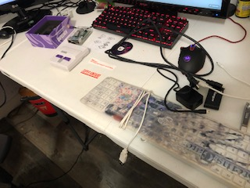

The first thing I did was remove the raspberry pi form it’s old case and remove the old heat sinks and prep the new heat sink for mounting. The new heatsink according kintaro is designed to keep the cpu and gpu at optimum operating temperatures to play retro games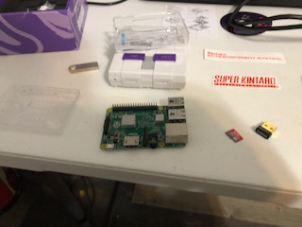

The following is the heat sink with the glue applied the heat sink is set up to be placed on the chips respectively based on size which is shown in the photo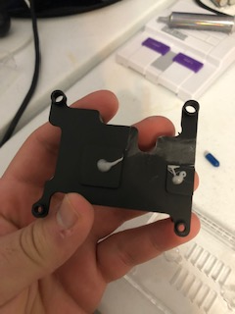

The heat sink if I can remember only has two screws. Which go mounted on the bottom end of the cpu that faces the GPIO.

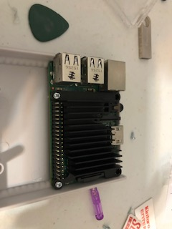

After mounting the heat sink and raspberry pi 2 into the bottom of the case you can now put on the top part and proceed to plug in the screws to the case. (warning: once the screws are in correctly I wish you luck taking them out. I tried to do it in class and they just didn’t budge) The case makes it obvious as to what screws go where the bigger holes get the bigger screws and the smaller holes get the smaller screws (you will have screws left over). (the guitar pic included in the pic was because I had to open the case before I put the screws in and reseat it to make sure it was flush.)

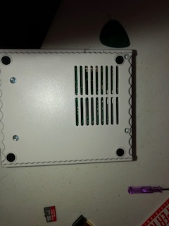

The following is the final product of what the super kintaro case with a raspberry pi 2 in it looks like  
after this it is time to flash the microsd card with retropie.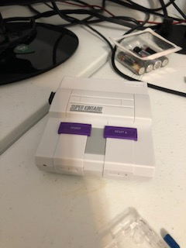

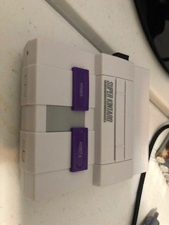

After doing some research I found that a very simple ISO burner program is one called [Etcher](https://www.balena.io/etcher/) which can be downloaded by clicking the hyper link(the iso needed is the [retropie](https://retropie.org.uk/) iso)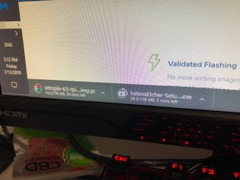

Next take the retropie ISO and select the media you want to flash via it’s gui(DO NOT FLASH THE USB) in this case we flash the micro sd.

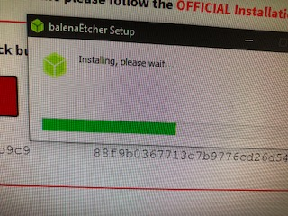

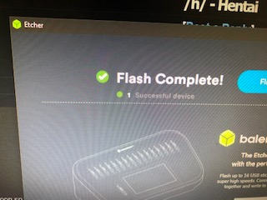

Now Something very cool about the retropie OS is that it can automatically make directories in our usb as long as we do the following:  
- put the usb into your computer  
-make 1 folder on your usb called **retropie** all lowercase

-eject the usb from the computer

The next step is to load the microsd card into the raspberry pi and power it on

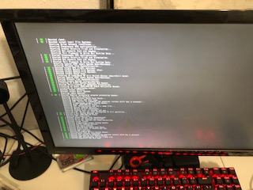

After it boots you should be greeted by the splash screen

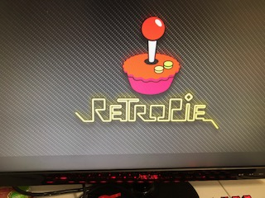

Then you’ll be greeted by the desktop(it says there’s one amiga game installed but there isn’t it’s just a gui config

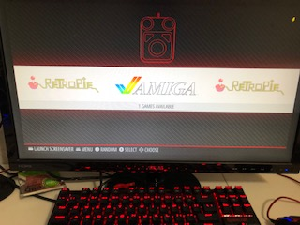

Now the directories aren’t going to be made right away what we’re going to do now is set up our controller

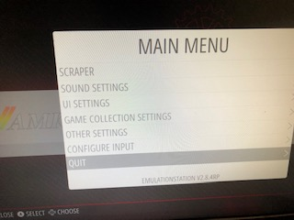

From the main menu you can go to configure input with the controller of your choice and you can configure input

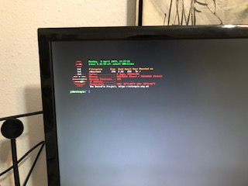Now we’re going to go into terminal and set up some configurations like wifi and making the sound on the n64 emulator not skip or sound as bad I will explain the n64 one as we go  
Press f4

To set up wifi we need to edit the wpa_supplicant.conf

**sudo nano /etc/wpa_supplicant/wpa_supplicant.conf**

here is what you type in that config

**country=US**

**ctrl_interface=DIR=/var/run/wpa_supplicant GROUP=netdev**

**update_config=1**

**network={**

**ssid=”put your wifi ssid here”**

**psk=”Your real password”**

**}**

Ctrl-o used to save press enter when prompted after pressing control o  
ctrl-x exit nano

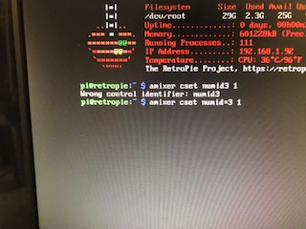Next we’re going to edit the audio

amixer cset numid=3 1 (1 is the audio jack)

amixer cset numid=3 2(2 is hdmi)

amixer means audio mixer

Now we will be editing the sound problem for the n64 on the current version of retropie all we need to do is the following:  
**sudo nano /opt/retropie/configs/all/autoconf.cfg**

The look for the line:

**mupen64plus_audio = “1”**

and change that to a

**mupen64plus_audio = “0”**

(use the sed command if it works)

make sure the line **RESAMPLE = “src-sinc-fastest”** is src-sinc-fastest if it isn’t change it to that

all of this will make the audio for the n64 sound better and not as choppy

Now because I was to lazy to go digging through my closet for my raspberry pi power supply I had to mess with the boot config and add in a line of code that allowed to run at turbo at all times no matter what was wrong. Having a block that outputs 5v doesn’t mean anything If the cable only outputs 2. During the creation of this retroconsole I had to redo everything simply because of the fact that the lack of proper power caused it to crash.:

**Sudo nano /boot/config.txt**

Add the line  
**avoid_warnings=2**  
ctrl-o

Ctrl-x

When back at terminal reboot so that way all the configurations and settings we changed may take effect.

Now, do you remember that usb with the retropie folder that was made?

Once at desktpp plug that into the pi for about 30 seconds to 1 minute(3 minutes) to be safe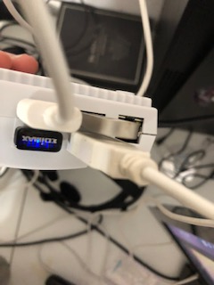

Once that is done plug the usb back into your windows computer navigate to the usb and double click the retropie folder. Now click roms.  
retropie automatically made rom folders for each individual console that the OS (and pi) can currently handle.

There is no need to unzip the roms that you download all you need to do is drag and drop them as zips as long as they are titled correctly for example NTSC roms has a U at the end or a J while PAL have an E

If your rom doesn’t have a header it may not run correctly

After you download the rom files just drag and drop them into their respective folders and eject the usb and put it back into the raspberry pi and reboot(or poweroff and then plug the usb in and turn the pi back on) and let the usb sit in the pi for a little bit (30 seconds or 3 minutes to be safe) afterwards reboot again and boot up. The roms should now be on the desktop with their respective consoles listed and they are now on the micro sd card you can keep the usb plugged in if you want it doesn’t affect the performance at all.